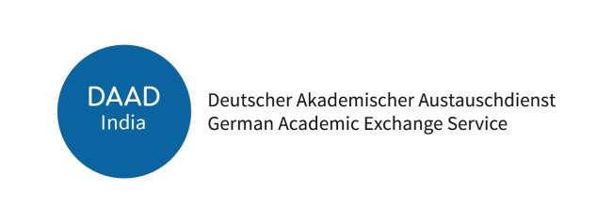

DAAD Regional Office in New Delhi invites applications for an
Internship – Marketing and Communications (40 hrs. per week)

About DAAD
Deutscher Akademischer Austauschdienst (DAAD) or the German Academic Exchange Service is a not-for-profit organization and is the largest funding organisation in the world supporting the international exchange of students and scholars.
The DAAD India promotes academic exchange between Germany and South Asia (India, Sri Lanka, Nepal, Bangladesh, and Bhutan). It provides information about institutions of higher education as well as research institutions in Germany. DAAD provides annual fellowships and short-term research grants, supports guest professorships, and helps to establish university collaborations.
Duties and Responsibilities of the intern:
Support to
- Create graphic & video content for the website and social media.
- Research, write, proofread, and edit newsletter content.
- Manage databases and statistics.
- Assist with information events.
- Coordinate the DAAD Young Ambassador network activities.
- Perform any other duty as assigned.
Knowledge, Skills, and Abilities:
- Minimum Qualification: Bachelor’s degree (Full-time and not older than 2021).
- MS Office skills (Outlook, Word, Excel, and PowerPoint), exposure to CMS such as WordPress, MailChimp and general office productivity tools.
- German language skills (B1 or above).
- Excellent written and verbal communication skills in English
- Self-motivated with high organisational skills.

DAAD • 3rd Floor • R.K. Khanna Stadium • 1 Africa Avenue • New Delhi 110029 • India • Tel: +91-11-6646 5500 • www.daad.in

Duration of the internship:
From 01.04.2024 to 15.12.2024
Full-time position, 40 hrs. per week
Workstation:
DAAD Office on 3rd Floor, R K Khanna Stadium, 1 Africa Avenue, New Delhi 110029
Note:
This is a paid internship without stay and travel allowance.
Application: https://www.daad.de/surveys/968518?lang=en
Apply online on:
Please upload the following documents on the above link at the end of the application in one pdf file of max. 5 MB:
- CV (Maximum 2 pages)
- German language certificate
- Academic degree certificates
- Any other documents (that may be relevant)

Application Deadline: 25.02.2024
Candidates who have applied earlier, need not apply again.
Only shortlisted candidates will be contacted for an interview.
Interviews are planned on 06.03.2024.

